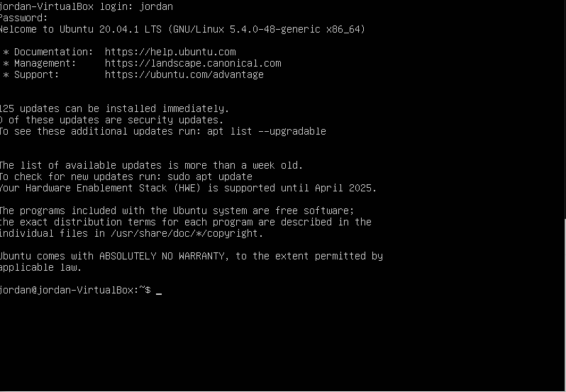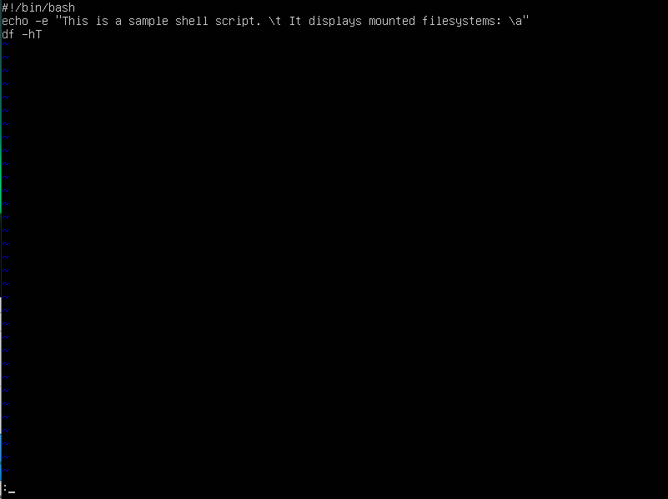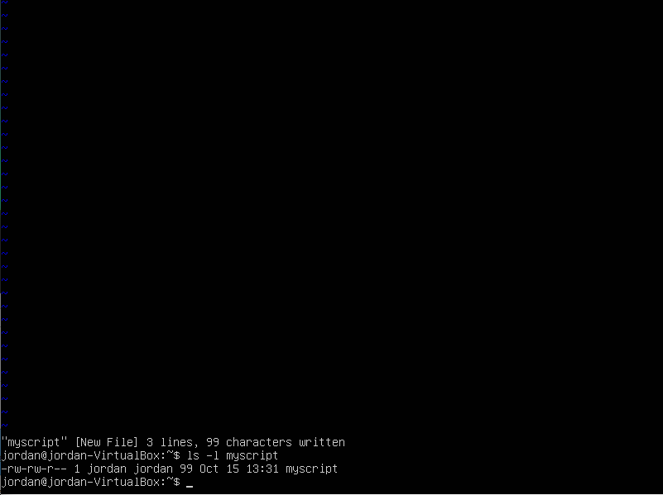the permission are read and write only. The /t is the horizontal tab and /a is the bell alert.

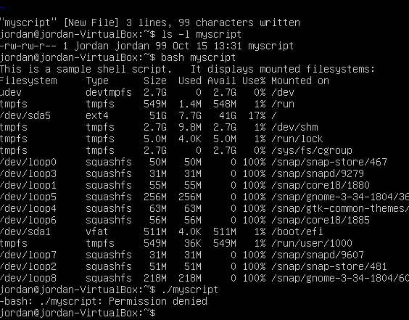

I got permission denied and maybe It got denied because im not authorized yet and I have to authorize using the chmod command to change the access permission of the file system.

